Requirements for this paper:
 | Multi choice cards: |  | Programmable calculator: |  |  | X |  |  | Open book examination
 | Graphic paper: |  | Laptop:
EKSAMEN/  EXAMINATION: |  |  |  | Semestertoets 2 Semester test 2 | kwalifikasieprogram/  /QUALIFICATION program:
modulekode/  Module CODE: |  |  |  | EERI 423 |  |  |  |  | duur/  duration: |  | 1.5 uur / 1.5 hours
module beskrywing/ module description: |  |  |  | Telekommunikasie / Telecommunication |  |  |  |  | maks / max:
EKSAMINATOR(E)/  examiner(s): |  |  |  | Prof A.S.J. Helberg |  |  |  |  | datum /  date: |  | 2017-05-23
 |  |  |  |  |  |  |  |  | tyd / time: |  | 11:00
moderator: |  |  |  | Prof J.E.W. Holm

Totaal / TOTAL: 50

Beantwoord die volgende vrae in u antwoordskrif:
Answer the following questions in your answerbook:

- Verduidelik met behulp van twee blokdiagramme die werking van FDM multipleksering en demultipleksering [8]
Use two block diagrams to explain the operation of FDM multiplexing and demultiplexing [8]

P350 and 351 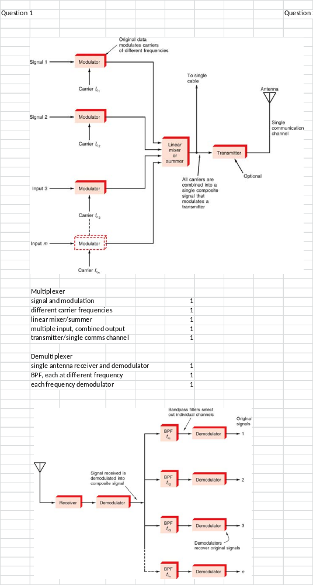

- Definieer elke term en verduidelik wat die verskil is tussen, TDM en TDD. [4]
Define each term and describe the difference between TDM and TDD.

Time Division Multiplexing and Time Division Duplexing [2]
Multiplexing used to combine different user’s signals based on a timeslot per user on the same frequency for transmission. [1]
Duplexing allows the receiver and transmitter to communicate simultaneously on the same frequency by assigning a complementary “talk-listen” timeslot approach [1]

- Die verlangde bistempo in ‘n kanaal is 100 kbis/s in ‘n 10 kHz kanaal.
a) Bereken die S/N (in dB) benodig vir die kanaal soos gedefinieer hierbo [3]
b) Hoeveel vlakke QAM moet gebruik word om die minimum bistempo te behaal? [2]
c) Indien die sein-tot-ruis verander na 20db, wat sal die effek op die stelsel wees?. [3]
The desired bit rate for a channel is 100 kbit/s in a 10 kHz channel
a) Calculate the S/N (in dB) required for the channel defined above [3]
b) What number of QAM levels must be used to achieve the minimum bit rate [2]
c) If the signal-to-noise changes to 20db, what will the effect on the system be? [3]

a) 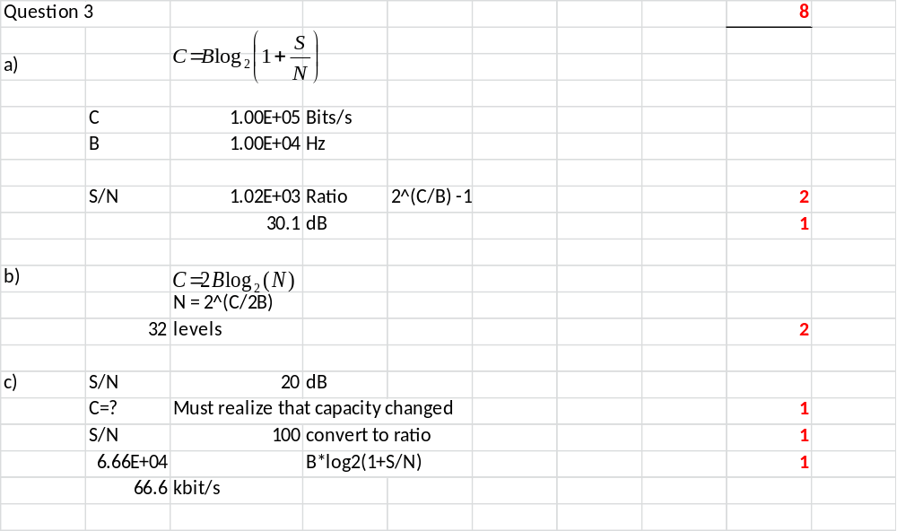

- Die volgende gegewens van ‘n radiosender en –ontvanger is bekend:
Sender antenna hoogte is 30m
Ontvanger antenna hoogte is 45m
Sender antenna wins is 12dBi meer as ‘n isotropiese straler
Ontvanger antenna wins is 3dBi meer as ‘n isotropiese straler
Die send en ontvang frekwensie is 250MHz
Die send drywing by die ingang van die antenna is 100W
Neem ‘n vrye-ruimte propagasiemodel as vertrekpunt en bereken
a) die maksimum send afstand moontlik indien die aarde as sferies aanvaar word [5]
b) die drywing by die uitgang van die ontvanger antenna indien die ontvanger 40km vanaf die sender geplaas word [9]
c) Indien ‘n deiningsmarge van 30dB gebruik word, bereken die ontvanger wins wees indien die uitset sein 20dBm is. [4]
The following parameters of a radio transmitter and receiver are known:
Transmit antenna height is 30m
Receive antenna Height is 45m
Transmit antenna gain is 12dBi over an isotropic source
Receive antenna gain is 3dBi over an isotropic source
The TX – Rx frequency is 250MHz
The power at the input of the transmitter antenna is 100W
Assume a free space propagation model and calculate the following:
a) the maximum transmitting distance assuming a spherical earth [5]
b) the power at the exit of the receiver antenna if the receiver is placed 40km from the transmitter. [9]
c) If a fading margin of 30dB is used, what should the receiver gain be if the output signal is 20dBm? [4]

ANSWER 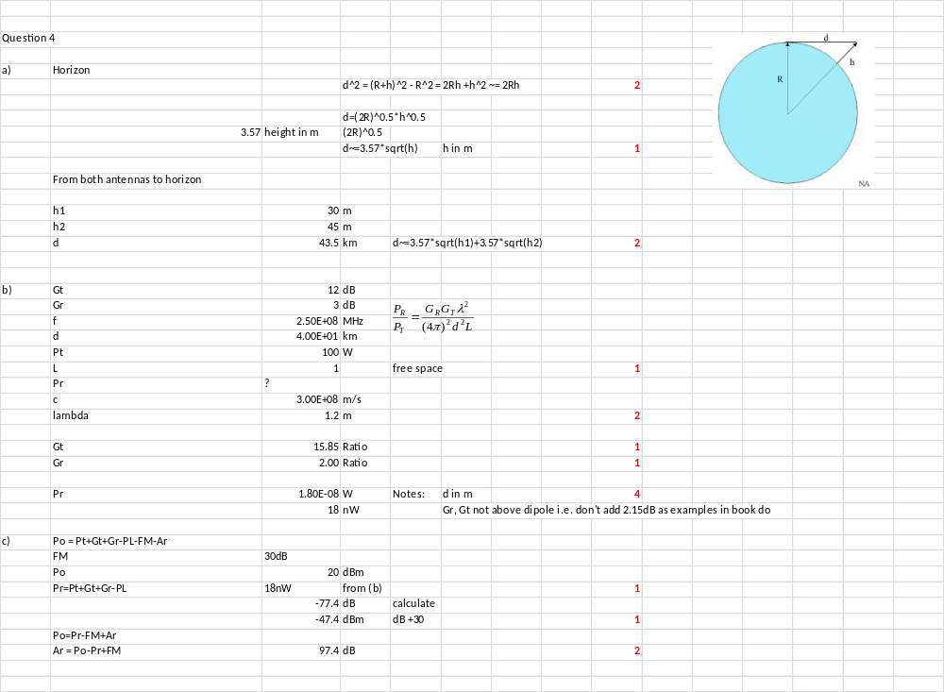

- a) Teken ‘n diagram van die hoëvlak argitektuur van ‘n GSM netwerk. Benoem elke component duidelik en gee die hooffunksie van daardie komponent. [3]
b) Gee die stappe wat gevolg word om ‘n oproep te konnekteer met bg argitektuur [9]
a) Draw the high level system architecture of a GSM network. Name each component and describe the main function of that component. [3]
b) List the steps required to connect a call when using the above architecture [9]

- BTS – Base Transceiver Station – Transmitter receiver station for the air interface to the mobile handset [1/2]
- BSC – Base stationController – aggregates A-Link signals from many BTS into single signal for backhaul to MSC [1/2]
- MSC - Mobile Switching Centre – Does voice call switching, user lookup etc. [1/2]
- VLR - Visitor Location Register - lists all users using BTS’s managed by the MSC [1/2]
- HLR - Home Location Register – lists BTSs where all users are. [1/2]
- EIR – Equipment Identification Register – lists valid (i.e. that may be used on this network) handset identification numbers. [1/2]

- Mobile handset requests mobile access channel from BTS over air-interface [1/2]
- BTS allocates traffic channel between mobile device and BSC. (ABIS interface between BTS and BSC) [1]
- Recipient mobile number is sent via BSC to MSC over A-interface [1]
- The subscriber details are verified using the VLR of that particular MSC [1/2]
- The EIR database is checked to see if the cellphone is not stolen or cloned [1/2]
- After checks, the MSC instructs BSC to assign voice channels and encryption for the call [1/2]
- The MSC contacts the HLR to find the corresponding MSC and uses the mobile subscriber ISDN to find the IMSI of the recipient of the call [1]
- These details are forwarded to the recipients MSC which generates a Mobile Station Roaming Number which is forwarded via the HLR to the caller’s MSC [3/2]
- The caller MSC routes the call through the network to the recipient MSC [1/2]
- The recipient MSC uses own VLR to find the recipients area code/location. [1/2]
- The MSC then broadcasts via BSC the recipients IMSI to all BTS in that area. [1/2]
- If the recipients handset recognizes its page, it starts to ring, and the caller hears a ringtone [1/2]
- An answered call establishes a channel along the same route back to the caller. [1/2]
[18/2=9]
Shortened version:
Mobile handset communicates via BTS and BSC to MSC which checks to see if subscriber is a valid user using the VLR and if the mobile handset is allowed on network using the EIR. [3]
The MSC then contacts HLR to find out at which MSC the recipient is, and sets up a switched path to that MSC. [2]
The recipients MSC uses own VLR to find out the right BTS for the recipient, and contacts that BTS to send a page to the recipient handset [2]
If the recipient recognizes the page, a ringtone is generated and a switched path back to the caller is set up along the same route. [2]
One point each for defining BTS, BSC, MSC EIR, VLR and HLR [6]

Formules EN TABELLE/ Formulas AND TABLES

Datakommunikasie / Data communication

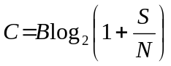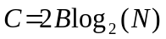
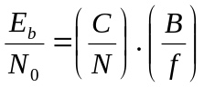
RF transmissie / RF transmission

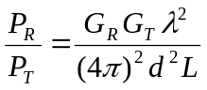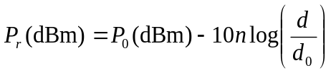
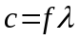 Radius of Earth = 6371km
Speed of light = 3e+08 m/s

Ontvangers, versenders en ruis / Receivers, transmitters, and noise

